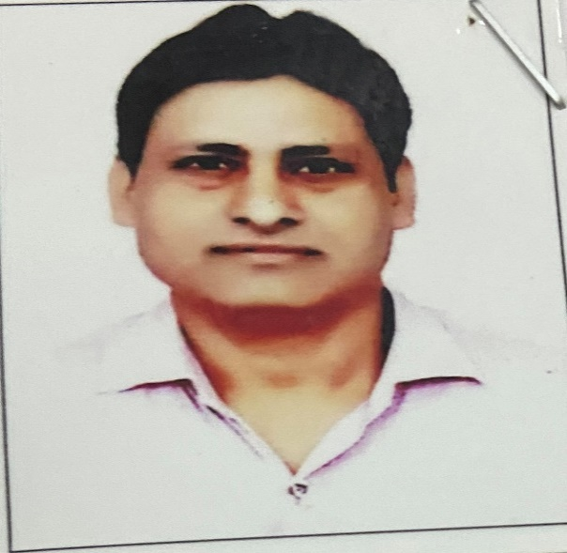
Ajay Chauhan
Assistant professor in Nimbus School of Education
Area
Primary Area: Education
Secondary Area: Science

Contact
Email: kchauhan.k80@gmail.com
Phone: +91-9759370398, 8273202121

Education
- M.Ed. from Jivaji University, Gwalior (M.P.)
- B.Ed. from C.C.S. University, Meerut.
- Post Graduate Diploma in Personal Management & Labour Welfare from Kurukshetra University.

Teaching
- Education
- Life Science
- Biology
- Zoology

Academic Experience
Faculty Member, William Jefferson Cliton Science Technology, Rampur, Maniharan, July 2005 onwards
Faculty Member, Shivalik College of Education, May 2008, onwards
Faculty Member, Krishna Institute of Education and Management, Saharanpur, June 2012, onwards
Faculty Member, Nimbus School of Education, _____________ onwards

Professional Experience
Nimbus School of Education
Nimbus Academy of Management

